VALENTINA LAGO RAAD

EBANX - TAKE HOME ASSIGNMENT

CURITIBA
2025
- Introduction
This document serves the purpose of presenting the solution proposed by the Software Engineering undergraduate student Valentina Lago Raad for the case study provided during the selection process at EBANX for a Junior Software Engineering position. The challenge consists of developing a RESTful API responsible for managing bank accounts and balances, including operations such as deposits, withdrawals, transfers and balance inquiries, according to predefined specifications.
The proposed challenge does not require the use of data persistence mechanisms, allowing the main focus to be placed on the solution design, code organization and the correct implementation of business rules. In this context, the exercise aims to assess not only the candidate's technical skills, but also their understanding of software development best practices, clarity in communicating technical decisions, and adherence to the defined requirements.
Throughout this document, the theoretical foundations to support the adopted solutions are presented, along with the elicitation and analysis of functional and non-functional requirements, as well as the implementation details, performed tests, and configuration management aspects. Finally, the conclusions drawn from the project development are discussed, highlighting the knowledge and experience gained during the process.
- Context and Problem Definition
The challenge proposed by EBANX consists of implementing a RESTful API for managing accounts and balances, enabling basic financial operations to be performed through HTTP requests. The API must expose specific endpoints for balance inquiries, financial event processing, and application state reset.
The supported operations include deposits, withdrawals, and transfers between accounts. Each operation follows clearly defined business rules, such as automatic account creation in deposit scenarios, the absence of an initial balance for non-existing accounts, and the return of appropriate error codes when invalid operations are requested. Request and response formats, as well as HTTP status codes, are explicitly specified and must be strictly followed.
A key aspect of the problem is the restriction regarding data persistence, allowing only temporary in-memory storage during application execution. This constraint removes concerns related to databases and data durability, directing the solution toward correct business logic implementation, code organization, and proper separation between the HTTP transport layer and domain rules.
Therefore, the problem requires a solution that is simple, predictable, and compliant with the specification, prioritizing clarity, correctness, and maintainability over optimizations or additional, non-required features.
- Theoretical Background
RESTful APIs (Representational State Transfer) represent one of the most widely adopted architectural styles in modern web application development, mainly due to their simplicity, standardization, and strong alignment with the HTTP protocol. This architectural model is based on the manipulation of resources identified by URIs (Uniform Resource Identifiers), using standardized HTTP methods to perform operations on these resources, thereby promoting interoperability and loose coupling between client and server (GOWDA; GOWDA, 2024).
The HTTP protocol plays a central role in communication between REST-based systems, being responsible not only for request transport but also for defining the semantics of responses. The proper use of HTTP methods, combined with the correct application of status codes, enables clients to clearly and objectively understand the outcome of each operation. According to Gowda and Gowda (2024), the correct application of these concepts directly contributes to the predictability, readability, and ease of integration of APIs, which are essential aspects of distributed systems.
Another fundamental principle of REST architecture is statelessness. In this model, each request must contain all the information necessary for its processing, without relying on server-side context maintained between consecutive calls. As stated by Gowda and Gowda (2024), this characteristic simplifies server logic, facilitates scalability, and reduces coupling between system components. Within the scope of the proposed challenge, the use of in-memory storage during application execution reinforces this principle by eliminating external dependencies related to data persistence.
Separation of concerns is widely recognized as a core principle of software engineering and is applied to improve system organization, maintainability, and clarity. As discussed by Gowda and Gowda (2024), a clear distinction between the HTTP transport layer and the business logic layer contributes to the safe and controlled evolution of RESTful APIs. This approach allows changes in one layer without directly impacting others, making future adjustments and extensions easier to implement.
Furthermore, simplicity in software design is a determining factor in the quality and sustainability of a solution. The adoption of best practices in REST API development encourages the creation of predictable, easy-to-understand, and maintainable systems over time (GOWDA; GOWDA, 2024). In challenges with a well-defined scope, such as the one proposed by EBANX, prioritizing simple solutions that strictly adhere to the specification is essential to ensure correctness, clarity, and ease of maintenance, while avoiding unnecessary complexity or out-of-scope features.
- Requirements Analysis
4.1 Functional Requirements
Identifier Code | Requirement Description
FR01 | The system shall provide an endpoint responsible for resetting the application state, removing all accounts and balances stored in memory.
FR02 | The system shall allow querying the balance of an existing account through an HTTP request, returning the value corresponding to the current account balance.
FR03 | The system shall return an appropriate error code, as defined in the challenge specification, when a balance inquiry is requested for a non-existing account.
FR04 | The system shall allow deposits to be made into a destination account. If the account does not exist, it shall be automatically created with a balance equal to the deposited amount.
FR05 | The system shall allow withdrawals from an existing origin account, updating the account balance after the operation.
FR06 | The system shall return an appropriate error code, without performing any changes to the application state, when a withdrawal operation is requested for a non-existing account.
FR07 | The system shall allow the transfer of funds between an origin account and a destination account, debiting the amount from the origin account and crediting it to the destination account.
FR08 | In transfer operations, if the destination account does not exist, the system shall automatically create it with a balance equal to the transferred amount.
FR09 | The system shall return an appropriate error code, without creating accounts or modifying balances, when a transfer is requested from a non-existing origin account.

4.2 Non-Functional Requirements
Identifier Code | Requirement Description
NFR01 | The system shall follow the principles of REST architecture, using well-defined resources, appropriate HTTP methods, and stateless communication.
NFR02 | The system shall correctly employ HTTP methods and status codes, ensuring semantic clarity in responses sent to the client.
NFR03 | The system solution shall be simple and objective, avoiding unnecessary complexity and features that are outside the scope of the challenge.
NFR04 | The code shall be clearly organized, facilitating readability, understanding, maintenance, and future modifications.
NFR05 | There shall be a clear separation between the layer responsible for handling HTTP requests and the layer responsible for implementing business rules.
NFR06 | The application state shall be maintained exclusively in memory during execution, without the use of database persistence mechanisms.

4.3 Constraint
Identifier Code | Constraint Description
C01 | The system shall exclusively implement the operations described in the challenge specification, with no expectation of additional functionalities such as authentication or concurrency control.
C02 | Request and response formats, as well as HTTP status codes, shall be strictly followed to ensure compatibility with the provided automated test suite.

- System Design and Architecture
5.1 Design Overview
The design of the proposed solution was structured based on the identified requirements and the principles of REST architecture discussed in the theoretical foundation, prioritizing simplicity, clarity, and separation of responsibilities. Considering the well-defined scope of the challenge, a lightweight architectural model was adopted, capable of fully meeting the specifications without introducing unnecessary complexity.
The application was conceived as a monolithic REST API, with state management handled exclusively in memory during runtime. This decision allows the design effort to focus on the correct implementation of business rules, code organization, and the predictability of the API’s behavior in response to incoming requests.
The design was documented through carefully selected UML diagrams, prioritizing those that best represent the domain structure and the execution flow of the system’s main operations.
5.2 Class Diagram
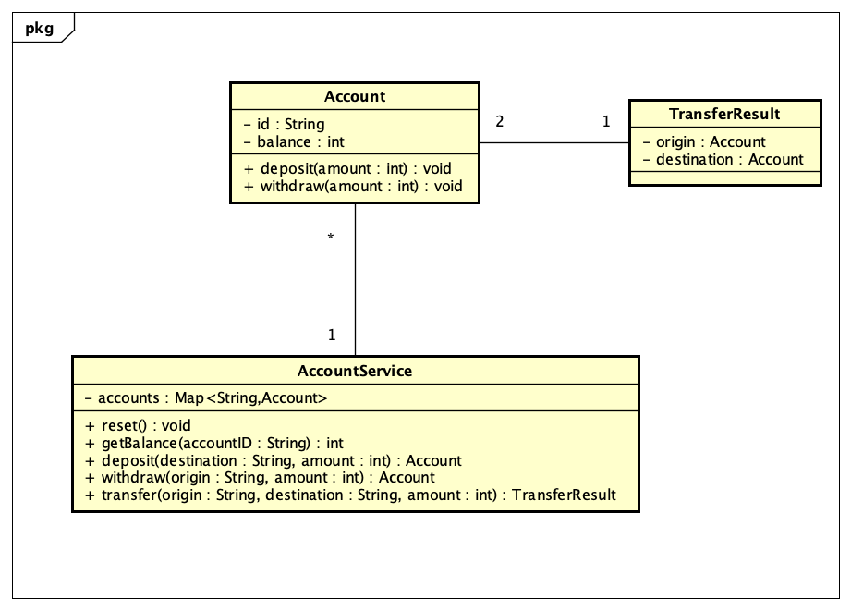
5.3 Sequence Diagrams
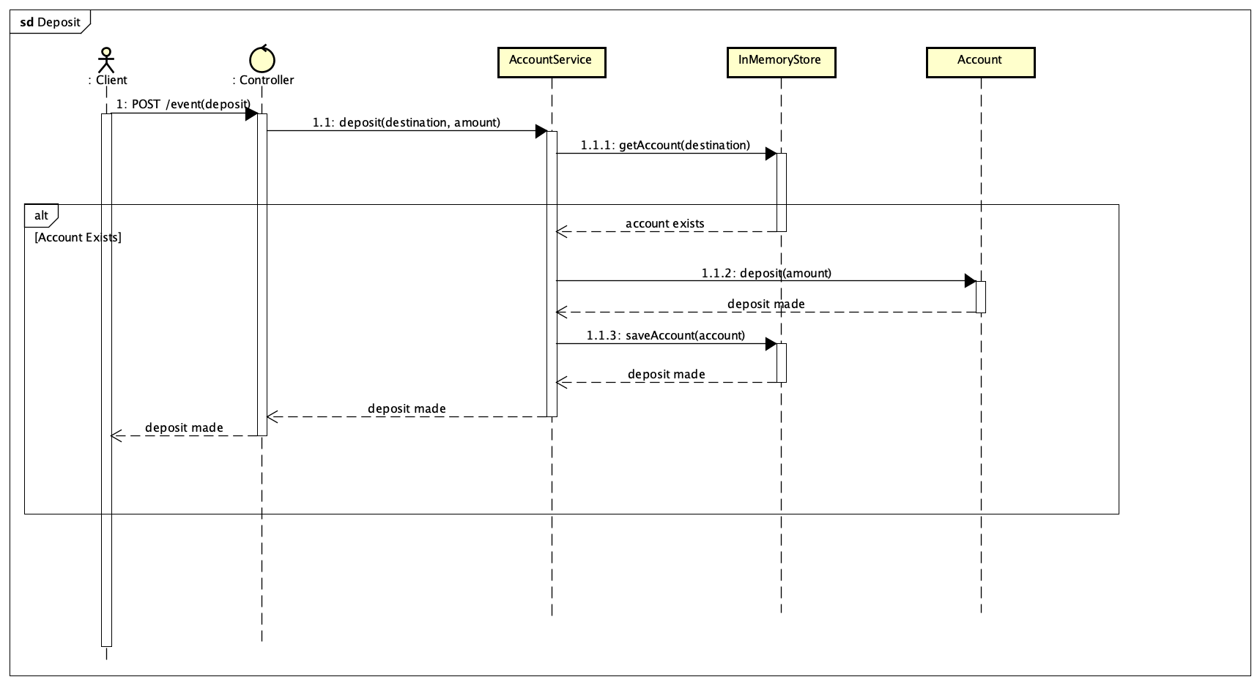
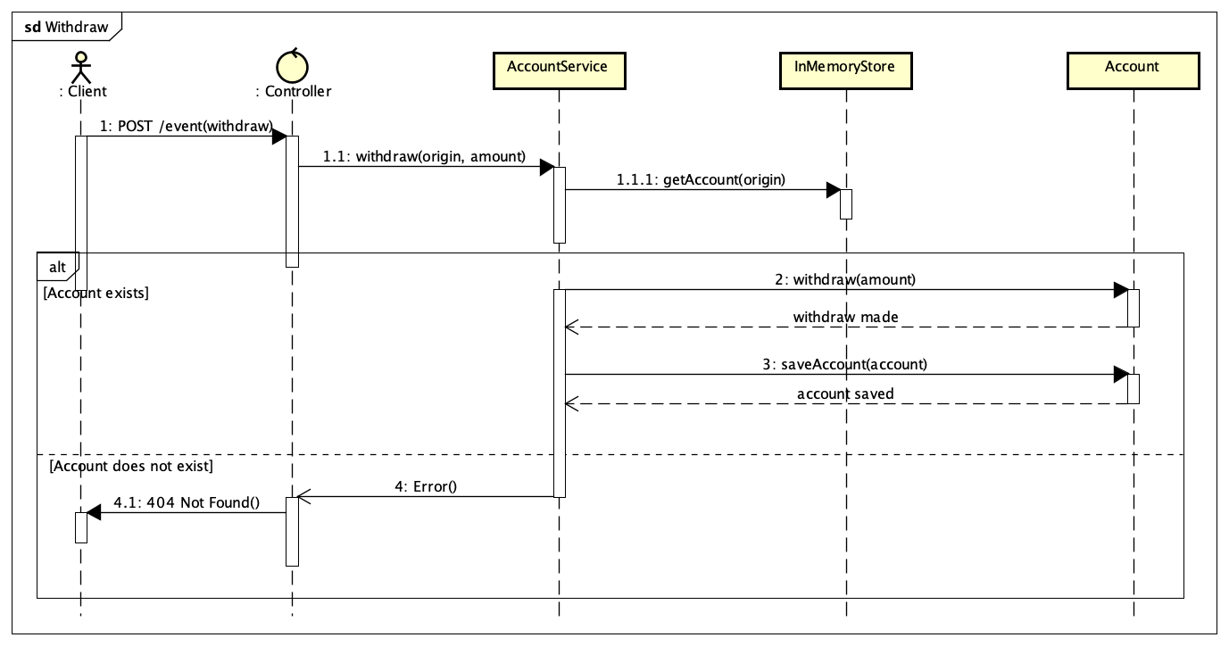
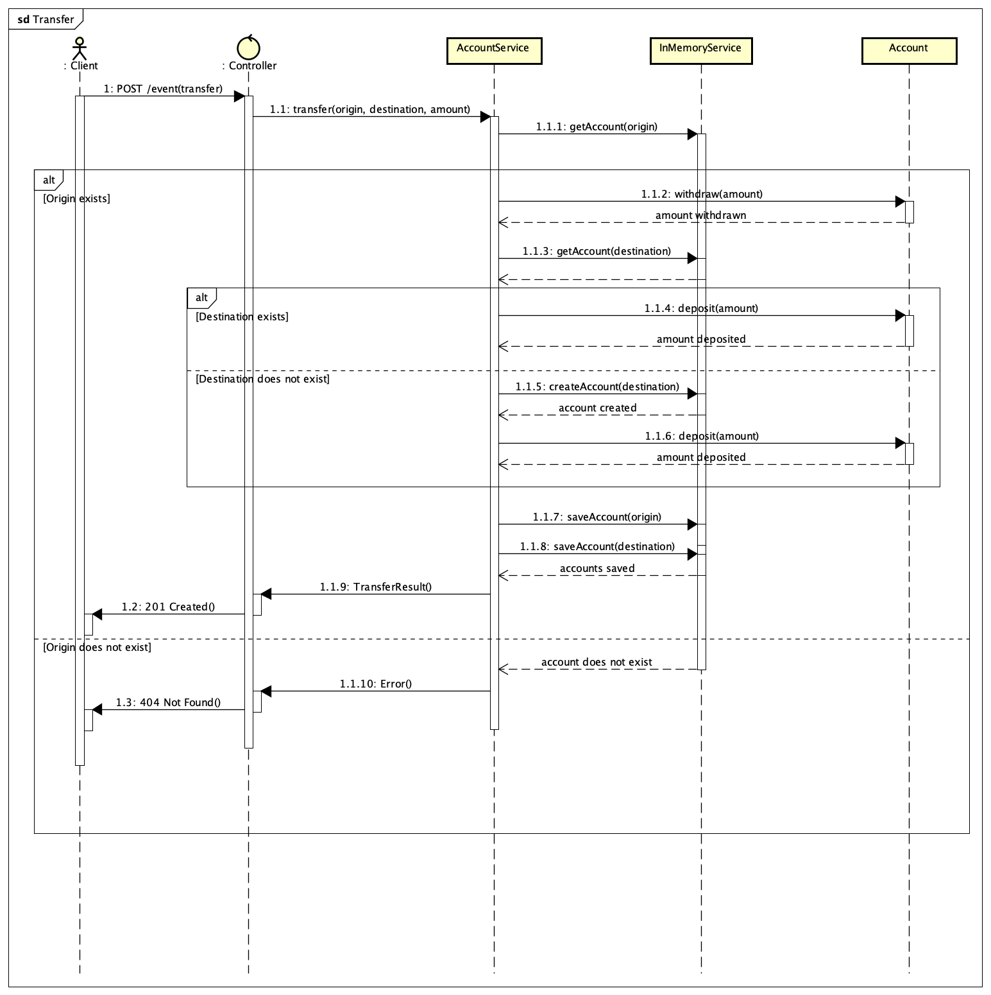
5.4 Design Considerations
The decision to document the solution using class and sequence diagrams proved appropriate for the project’s scope, as these artifacts directly represent both the static structure and the dynamic behavior of the application. This approach avoids the inclusion of redundant or low-value diagrams, keeping the focus on the most critical aspects of the system.
The resulting design exhibits low coupling, high cohesion, and clear responsibility boundaries among components—key characteristics for the maintainability and evolution of software systems. Therefore, the proposed architecture fully satisfies the identified functional and non-functional requirements while remaining simple, readable, and aligned with software engineering best practices.
- Implementation
The solution was implemented using the following technologies: Java 24 programming language, SprintBoot 3.5.10 framework, Maven as build tool, IntelliJ IDEA as the development environment, Render as the deployment platform, GitHub for verison control. The choice of Spring Boot as the development framework is justified by its wide adoption in the industry, extensive documentation, built-in support for REST API development, and the principle of convention over configuration, which accelerates development while maintaining code quality.
Regarding some key design decisions on the domain layer, I used BigDecimal for monetary values since it ensures exact decimal precision, avoiding rounding errors inherent to floating-point types. This is critical for financial applications where precision is mandatory. Balance modifications are performed exclusively through controlled methods (deposit and debit), preventing direct manipulation and ensuring business rule consistency. Also, the account identifier cannot be modified after creation, reflecting the real-world constraint that account numbers are permanent.
Regarding some key design decisions on the service layer, in-memory storage through a HashMap provides an average-case lookup performance and satisfies the no persistence requirement. The deposit method creates accounts automatically if they don't exist. Methods return null when operations fail, delegating HTTP status code handling to the controller layer. The @Service annotation marks the class as a Spring-managed service component, enabling dependency injection.
Regarding some key decisions on the controller layer, the @RestController annotation combined @Controller and @ResponseBody, automatically serializing return values to JSON. AccountService is injected via constructor, following Spring Boot best practices and facilitating testability. ResponseEntity usage provides fine-grained control over HTTP status codes (200, 201, 404) as required by the specification. The /event endpoint uses request body discrimination to route to appropriate business logic, following the provided specification.
The Data Transfer Objects (DTOs) decouple the internal domain model from external API contracts. The EventRequest captures incoming JSON for deposit/withdraw/transfer operations. The DepositResponse/WithdrawResponde wrap account objects with appropriate field names. The TransferResult contains both origin and destination accounts for transfer responses. This separation allows internal model changes without affecting the API contract, improving maintainability.
- Testing Strategy and Adjustments
Given the project's scope and time constraints, aside from the automated test suite provided for the challenge, manual testing was performed using curl commands to verify all functional requirements against the specification.
All nine test cases from the specification were executed.
Test Case | Expected Result | Actual Result | Status
POST /reset | 200 OK | OK | Pass
GET /balance (non-existent) | 404 0 | 0 | Pass
POST /event (deposit, new) | 201 + JSON | Correct JSON | Pass
POST /event (deposit, existing) | 201 + JSON | Correct JSON | Pass
GET /balance (existing) | 200 + balance | Correct balance | Pass
POST /event (withdraw, non-existent) | 404 0 | 0 | Pass
POST /event (withdraw, existing) | 201 + JSON | Correct JSON | Pass
POST /event (transfer, existing) | 201 + JSON | Correct JSON | Pass
POST /event (transfer, non-existent) | 404 0 | 0 | Pass

The deployed application at https://ebanx-api-challenge.onrender.com was tested with the complete test suite confirming that all endpoints function correctly in the production environment.
The application was configured to use dynamic port assignment through the server.port=${PORT:8080} property, enabling deployment on platforms like Render that assign ports dynamically.
The implementation passed all tests on the first attempt, demonstrating that careful requirement analysis and design prevented the need for significant corrections.
- Configurations and Version Control Management
The development of this project was conducted with careful attention to configuration management and version control practices, ensuring traceability of decisions and facilitating collaboration and code review processes.
Version control was implemented using Git, with the complete project history hosted on GitHub at the repository https://github.com/vlagoraad/ebanx-api-challenge . The adopted commit strategy prioritized incremental progress, with each commit representing a logical and complete unit of work. Commit messages followed the conventional commit format, providing clear descriptions of the nature and scope of each modification. Examples include messages such as "feat: add Account domain model with deposit and withdraw operations," "feat: implement service layer with all banking operations," and "build: add Dockerfile for deployment." This approach not only documents the project's evolution but also facilitates understanding of architectural and implementation decisions made throughout the development process.
The project's build configuration was managed through Maven, defined in the pom.xml file located at the project root. Maven coordinates dependency management and build automation, ensuring reproducibility across different development environments. The primary dependencies include spring-boot-starter-web, which provides comprehensive support for building REST APIs, and spring-boot-devtools, which enhances the development experience through features such as automatic application restart during code changes. The Maven wrapper (mvnw) was included in the repository to guarantee that all developers and build environments use a consistent Maven version, eliminating potential compatibility issues.
For deployment purposes, a multi-stage Dockerfile was created to optimize both build efficiency and final image size. The first stage, based on the eclipse-temurin:21-jdk-alpine image, handles compilation and packaging using Maven, producing the executable JAR artifact. The second stage, using eclipse-temurin:21-jre-alpine, creates the minimal runtime environment containing only the compiled application and the Java Runtime Environment. This separation reduces the final Docker image size significantly while maintaining all necessary functionality for execution.
Application configuration for deployment was handled through the application.properties file, where the server port was configured using the expression server.port=${PORT:8080}. This configuration enables the application to run on dynamically assigned ports in cloud environments while maintaining compatibility with local development environments that default to port 8080. This flexibility was essential for successful deployment on the Render.com platform.
The deployment itself was configured on Render.com, utilizing their free tier for hosting. The application is publicly accessible at https://ebanx-api-challenge.onrender.com and is configured for automatic deployment whenever changes are pushed to the main branch of the GitHub repository. The deployment configuration specifies banking-api as the root directory, uses Docker as the build method, and maintains automatic deployment enabled to facilitate continuous integration practices. This setup ensures that the latest version of the application is always available in the production environment, with minimal manual intervention required for deployment operations.
- Limitations and Future Improvements
While the implemented solution successfully fulfills all requirements specified in the challenge, it is important to acknowledge certain inherent limitations that, although acceptable within the project's defined scope, would require attention in a production-ready system.
The most significant limitation concerns data persistence. As required by the challenge specification, the application maintains all state exclusively in memory during execution. This design decision, while simplifying the implementation and focusing attention on business logic and API design, results in the complete loss of all account data whenever the application restarts. In a real-world banking system, this characteristic would be unacceptable, as data durability and reliability are fundamental requirements for financial applications.
Concurrency control represents another area where the current implementation exhibits limitations. The system does not incorporate mechanisms to safely handle simultaneous requests operating on the same account. In scenarios where multiple clients attempt to perform operations concurrently on a single account, race conditions could occur, potentially leading to inconsistent balance calculations. While this issue may not manifest during sequential testing or low-traffic scenarios, it would pose serious risks in production environments with multiple concurrent users.
Input validation in the current implementation is minimal, operating under the assumption that incoming requests are well-formed and contain valid data. The system does not actively validate constraints such as ensuring amounts are positive values, rejecting requests with negative or zero amounts, or verifying that account identifiers conform to expected formats. Additionally, the handling of null or missing fields in request bodies relies on default Spring Boot behavior rather than explicit validation logic. While this approach reduces code complexity and aligns with the challenge's emphasis on simplicity, it leaves the system vulnerable to unexpected behavior when confronted with malformed or malicious requests.
Error handling, while functionally correct according to the specification, provides minimal information to API consumers. For instance, when a 404 error occurs, the response body simply contains "0" without additional context or explanation. While this format strictly adheres to the provided specification, more descriptive error messages including error codes, human-readable descriptions, and timestamps would significantly improve the developer experience when integrating with or debugging the API.
The absence of automated testing represents a notable gap in the project's quality assurance strategy. All verification was performed through manual testing using curl commands, which, while effective for demonstrating compliance with requirements, lacks the repeatability, coverage, and regression detection capabilities that automated test suites provide. The lack of unit tests for business logic, integration tests for API endpoints, and contract tests for request-response formats means that future modifications carry increased risk of introducing defects.
Looking toward future enhancements, several improvements would substantially increase the system's robustness and production readiness. Database integration would address the persistence limitation, with technologies such as PostgreSQL for production environments or H2 for development and testing providing reliable data storage. The adoption of Spring Data JPA would facilitate this integration while maintaining clean separation between business logic and data access concerns.
Concurrency issues could be resolved through the implementation of transaction management using Spring's @Transactional annotation combined with appropriate isolation levels, or through optimistic locking mechanisms using version fields in domain entities. These approaches would ensure data consistency even under high-concurrency scenarios without significantly compromising performance.
Comprehensive input validation could be achieved through Bean Validation annotations such as @Valid, @NotNull, @Positive, and custom validators for complex business rules. This declarative approach would centralize validation logic and provide clear, consistent error responses when invalid data is encountered. Structured error responses following a standard format such as RFC 7807 (Problem Details for HTTP APIs) would improve API usability and facilitate client-side error handling.
The development of a complete automated test suite would significantly enhance confidence in the system's correctness and facilitate future modifications. Unit tests using JUnit 5 and Mockito would verify business logic in isolation, while integration tests using Spring Boot's @SpringBootTest and MockMvc would validate the behavior of complete request-response cycles. The adoption of test-driven development practices in future iterations would further improve code quality and design.
API documentation generated through tools such as Swagger or OpenAPI would provide interactive documentation allowing developers to explore and test endpoints directly through a web interface. This improvement would reduce the learning curve for new API consumers and serve as living documentation that remains synchronized with the actual implementation.
Finally, as the system evolves beyond a prototype, security considerations would become paramount. The implementation of authentication mechanisms to verify user identity, authorization controls to restrict access to specific operations based on user roles, and audit logging to track all financial transactions would transform the system into one suitable for real-world financial operations.
- Conclusion
This project successfully implemented a RESTful API for bank account management that fully satisfies all specifications provided in the EBANX technical challenge. The solution demonstrates proper application of REST architectural principles, clear separation of concerns between layers, and adherence to software engineering best practices.
The implementation process reinforced a fundamental principle of software development: simplicity and strict adherence to requirements often yield superior results compared to over-engineered solutions. By maintaining focus on the specified requirements and avoiding unnecessary complexity, the project achieved a clean, functional implementation that passed all test cases in both local and production environments.
From a technical perspective, the project provided valuable hands-on experience with Spring Boot framework, REST API design, dependency injection, containerization with Docker, and cloud deployment workflows. The successful deployment at https://ebanx-api-challenge.onrender.com confirms the solution's viability in a production-like environment.
While the current implementation meets all challenge requirements, the identified limitations—such as lack of data persistence, concurrency control, and automated testing—highlight the natural evolution path toward a production-ready system. These limitations, though acceptable within the project's scope, provide important insights into the additional considerations required for real-world financial applications.
In summary, this challenge effectively demonstrated the ability to analyze requirements, design appropriate solutions, implement clean code with proper architectural separation, and deploy functioning applications to the cloud. The experience gained represents meaningful progress in developing professional software engineering competencies.
- Bibliographical References
AUGUSTINE, J. et al. REST API Architecture and Design Principles. International Journal of Computer Science and Information Technology, v. 14, n. 3, p. 45–52, ago. 2023.

FIELDING, Roy Thomas. Architectural Styles and the Design of Network-based Software Architectures. 2000. Tese (Doutorado em Ciência da Computação) – University of California, Irvine, Irvine, 2000.

GOWDA, N.; GOWDA, P. Best Practices in REST API Design for Enhanced Scalability and Security. International Journal of Advanced Research in Engineering and Technology (IJARET), v. 15, n. 1, p. 1–10, 2024.

IETF. RFC 9110: HTTP Semantics. Internet Engineering Task Force, 2022. Disponível em: https://www.rfc-editor.org/rfc/rfc9110. Acesso em: 18 dez. 2025.

